|  |  |
| --- | --- |
| EX NO : 06 | CHANGING THE VIRTUAL MACHINE DISPLAY |
| DATE : 08.02.2023 |

AIM :

To change the virtual machine display in VMWare workstation 16 pro.

PROCEDURE :

STEP 1 : Open VMWare workstation 16 pro in your pc.

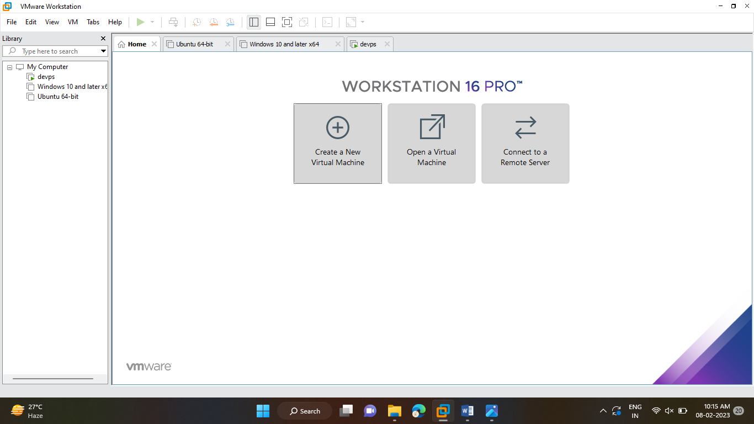

STEP 2: Click edit option 🡪 Click preference then preference pop up will be shown.

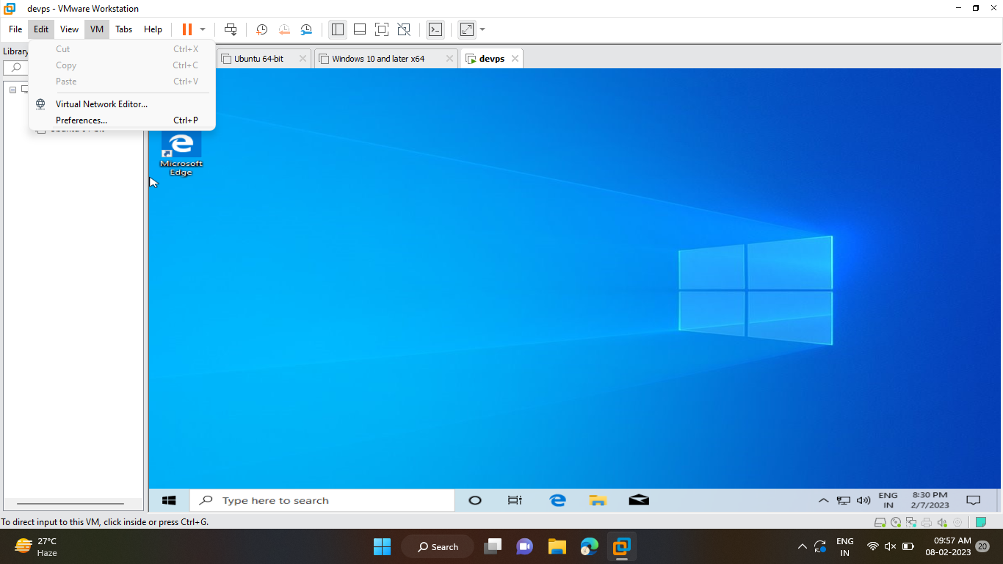

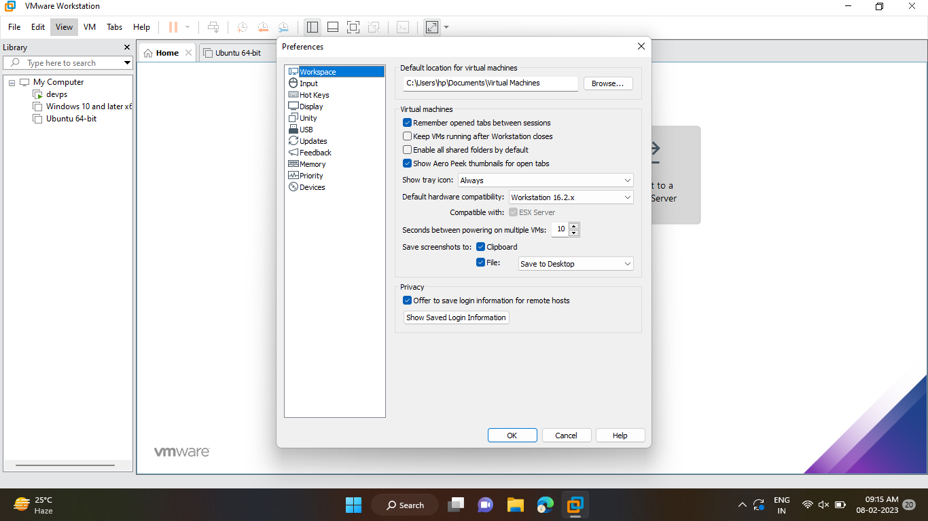

STEP 3 : In preference click display to change the autofit.

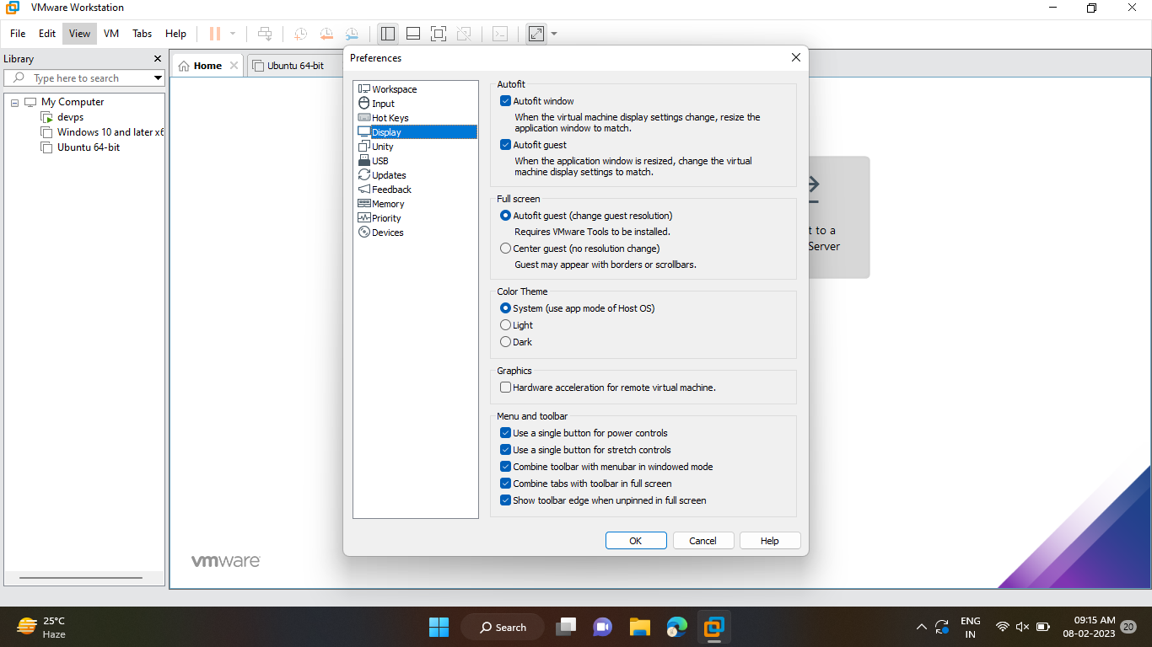

STEP 4: In autofit click autofit window to resize the application window.

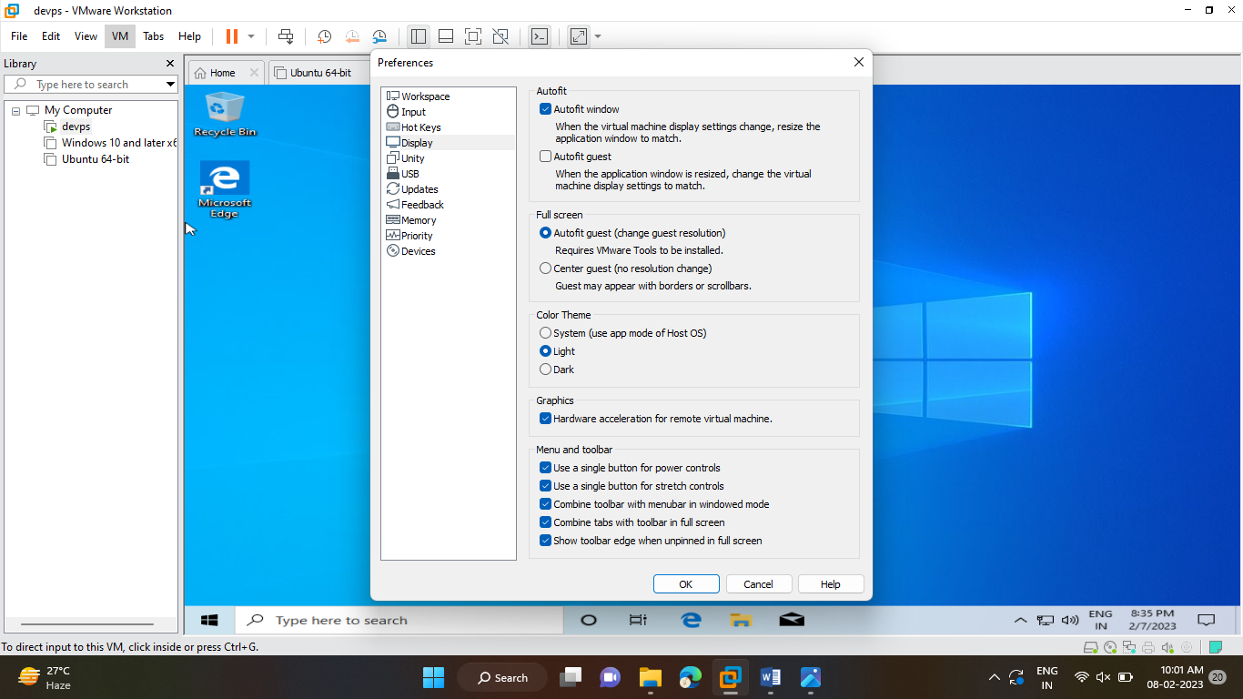

STEP 5 : In autofit click autofit guest to change the virtual machine display settings.

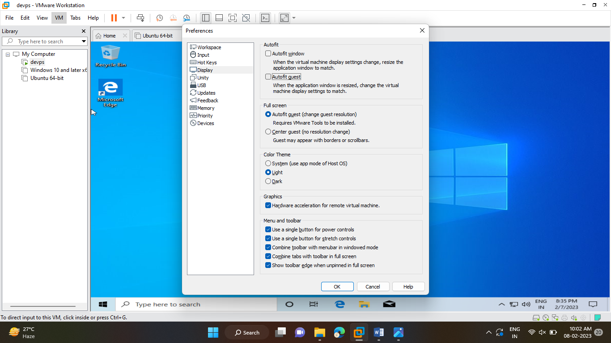

STEP 6: In fullscreen 🡪click Autofit Guest for changing the guest revolution.

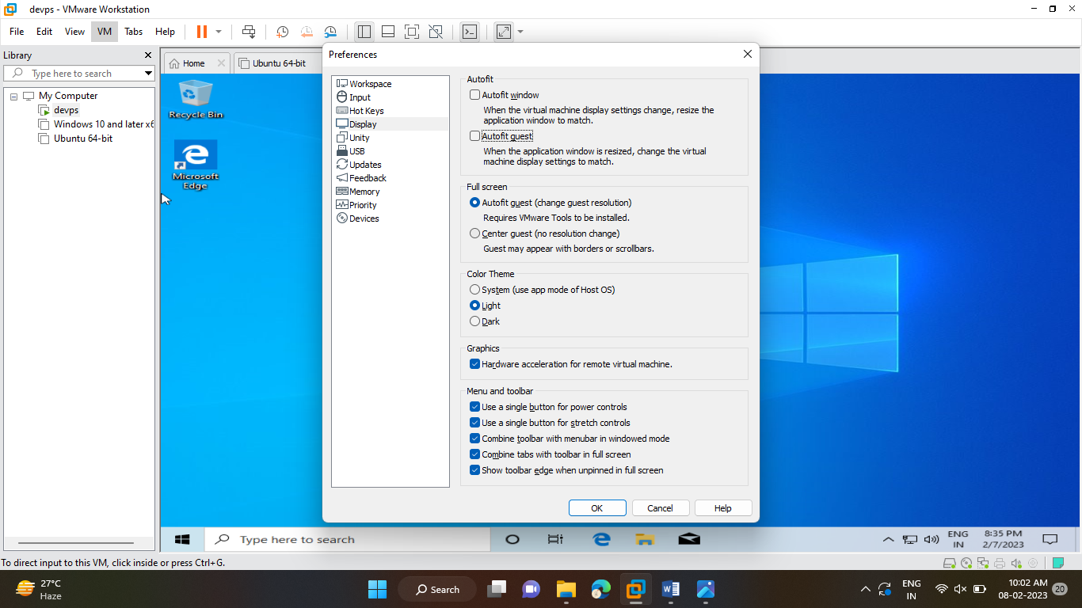

STEP 7 : In color theme choose light 🡪 click ok.

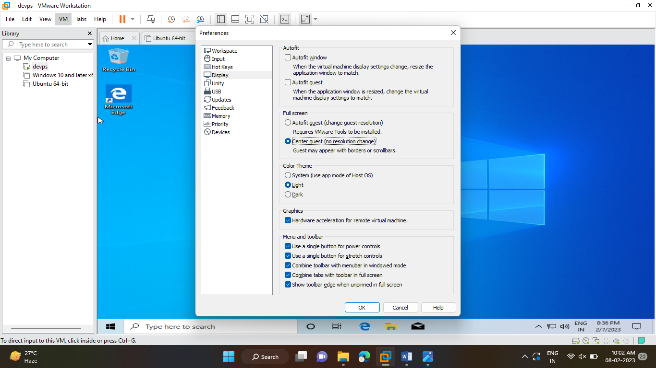

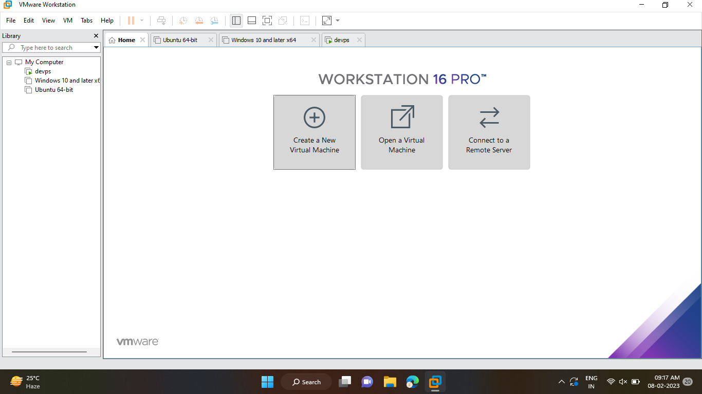

STEP 8 :In color theme choose System 🡪 click ok.





STEP 9 :In color theme choose dark 🡪 click ok.

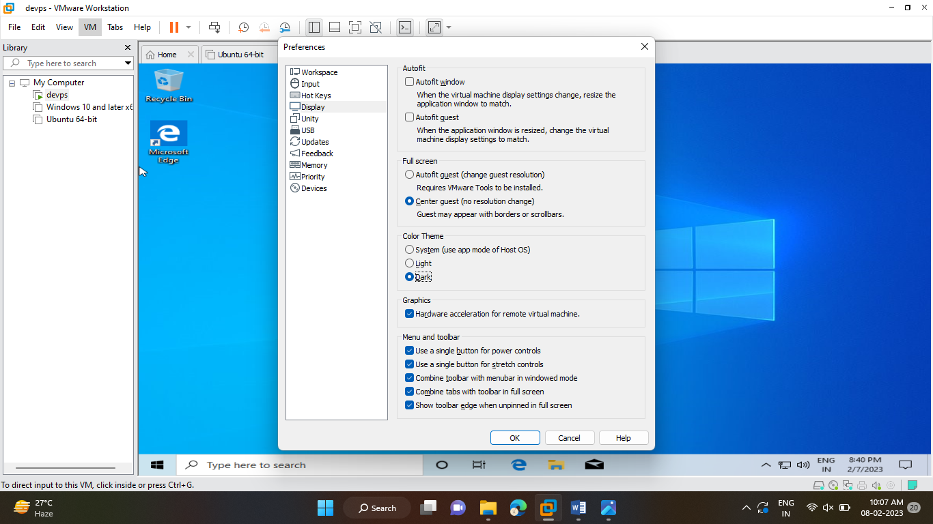

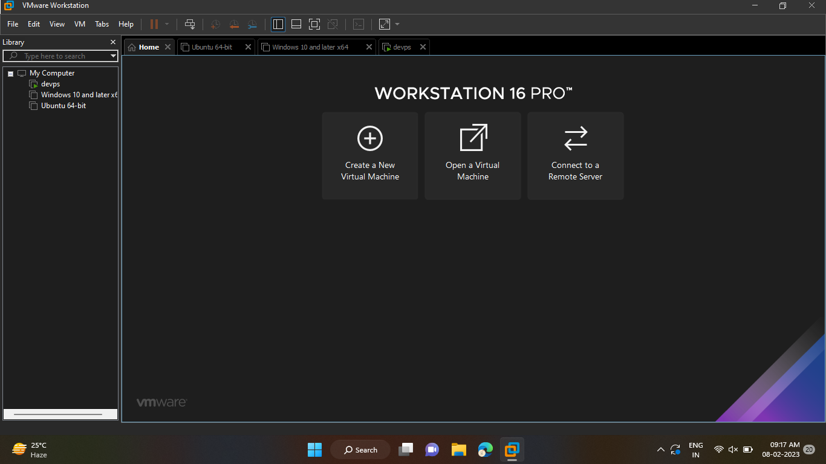

STEP 10 : In display as we have graphics settings 🡪 click Hardware acceleration for remote virtual machine 🡪 click ok.

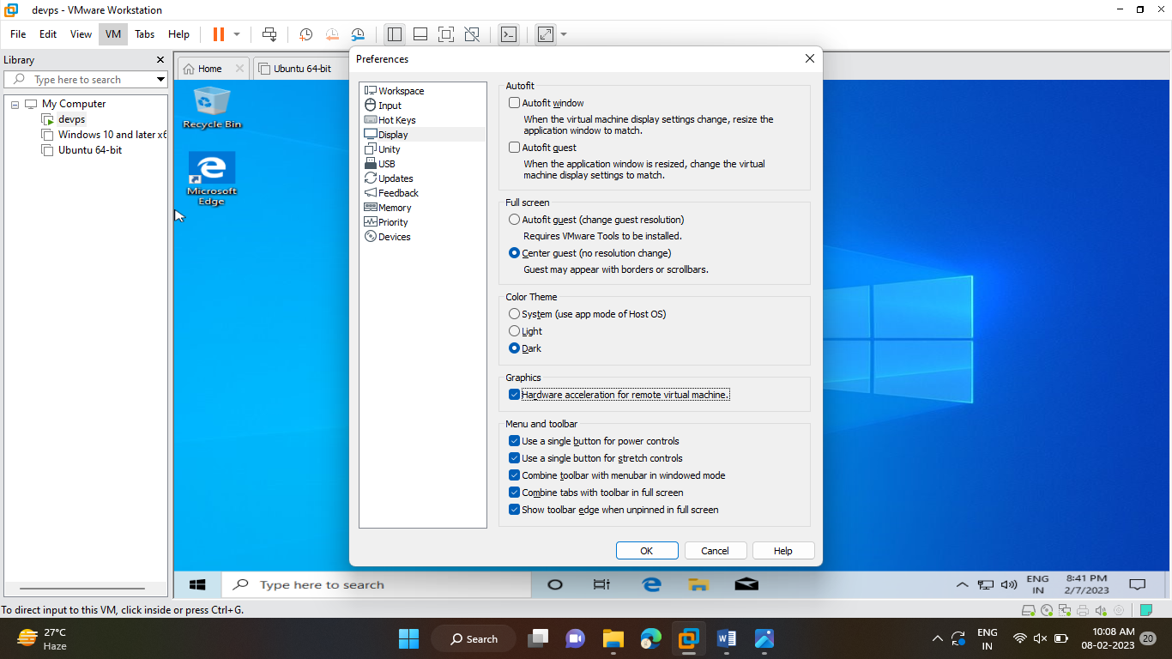

STEP 10 : In menu and toolbar settings 🡪 choose any features 🡪 click ok.



STEP 11 : Click view 🡪 click full screen or click ctrl+alt+enter.

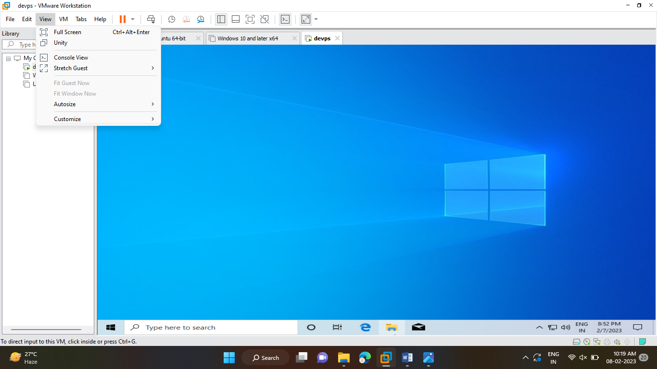

RESULT:

The changing the virtual machine display in VMWare Workstation player has been completed successfully.